Blake Segars

Github Upload Test – Sage math examples

**Solving equations**

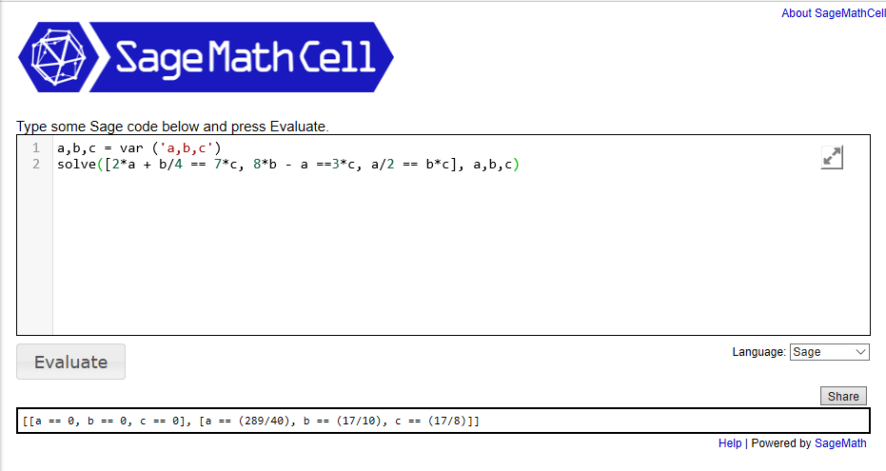

**Plotting**

